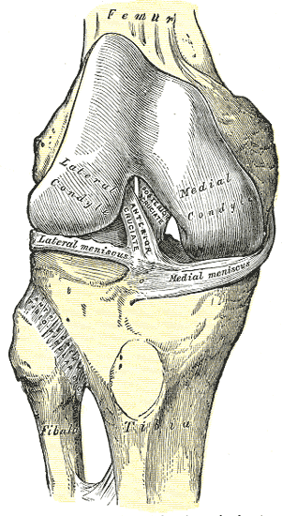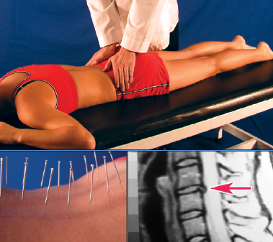

**Medial Collateral Ligament Sprain**

**We Can Help**

1234 Any Street North

Townsville, State 54321

604.521.5520 ph

604.521.5526 fax

www.prohealthsys.com

**ProHealth Clinics**

Your Clinic Logo or Staff Picture

consultation

diagnosis

support

**Prognosis & Prevention**

* **Most patient experience benefits through conservative care**
* **Future prevention is a fundamental part of our management plan & includes…**

Professional Health

Your Clinic Name

**How can we help?**

* **Physical therapy:** Ultrasound and laser therapy to help increase range of motion
* **Hydrotherapy:** contrast hydrotherapy to promote circulation and healing
* **Nutrition:** many vitamins, minerals & botanicals contain pain-relieving & anti-inflammatory properties
* **Acupuncture:** may help increase circulation and pain relief
* **Prolotherapy and PRP**: injections that may help tissue healing

References:

* Lind. M. et al. 2009. Anatomical reconstruction of the medial collateral ligament and posteromedial corner of the knee in patients with chronic medial collateral ligament instability. *Am J Sports Med*. 37(6), 1116-22.
* Mizusaki, A. et al. 2011. Effectiveness of electrical stimulation on rehabilitation after ligament and meniscal injuries: a systematic review. *Sao Paulo Med J*. 129(6), 414-23

Taylor, D.W. et al. 2011. A systematic review of the use of platelet rich plasma in sports medicine as a new treatment for tendon and ligament injuries. *Clin J Sport Med*. 21(4). 344-52.

**History, signs & symptoms**

* Most often happens on a planted foot with an excessive force coming from the lateral side of the knee.
* OR with a cleated foot, lower leg twists excessively
* May hear "pop" sound
* Tenderness, swelling, instability at medial knee
* Exercise will be inhibited, increased swelling and pain may cause one to decrease their activities of daily living

We have the training and experience to work with you as part of your healthcare team.

Acute flare-up to regular maintenance, we can support your return to optimal health.

**Condition – What is it?**

* A tear in the ligament supporting the inside of the knee
* Causes instability at the knee joint
* Can be from a 1% tear to a complete rupture
* Risk factors: contact sports, previous MCL sprain, knocked knees, playing surface, fatigue, and cleated sports
* Weak supporting muscles may leave you at risk

**Treat the underlying cause.**

**Effective, Comprehensive, holistic & safe.**