**Tennis Leg**

**Aka: Gastrocnemius Strain**

**Copyright free images**

**from prohealthsys.com**

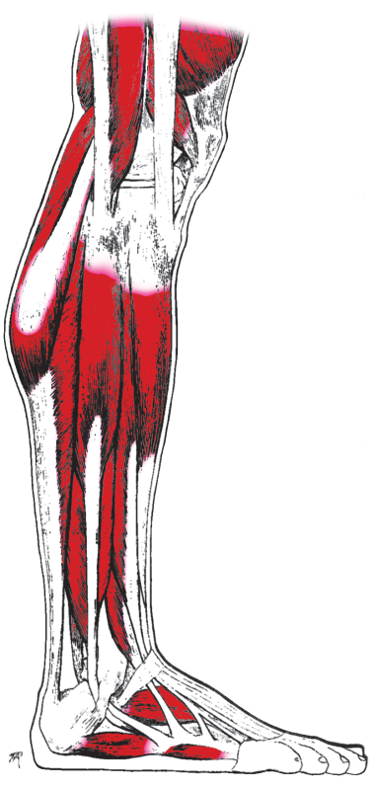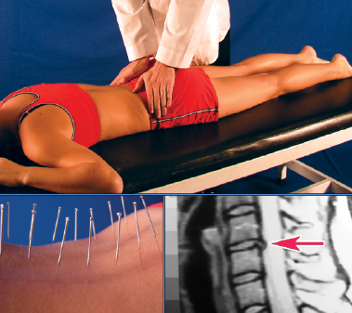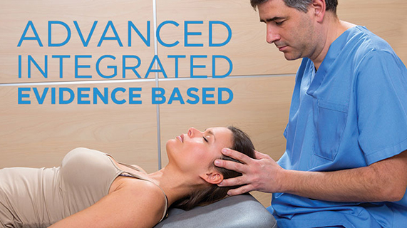

**We Can Help**

1234 Any Street North

Townsville, State 54321

604.521.5520 ph

604.521.5526 fax

www.prohealthsys.com

**ProHealth Clinics**

Your Clinic Logo or Staff Picture

consultation

diagnosis

support

**Prognosis & Prevention**

* **Prevention:**
  + **Warm up and stretch properly before activity**
  + **Learn and use proper exercise technique**
  + **Allow for adequate recovery between workouts**
* **Prognosis:**
  + **If treated properly, tennis leg usually heals within 6 weeks.**

Professional Health

Your Clinic Name

**History, signs & symptoms**

* Common to tennis players or athletes of age 30-50, more common in men
* Signs and Symptoms:
  + Pain describe as being shot in the leg
  + Sudden pop or tear felt at the time of injury
  + Pain, tenderness, swelling, warmth or redness over the middle inner calf.
  + Pain and weakness with ankle movement especially flexing and extending the ankle.
  + Muscle spasm in the calf

**How can we help?**

* **Physical therapy:** to maintain and improve range of motion & decrease pain
* **Hydrotherapy:** contrast hydrotherapy to promote circulation and healing
* **Nutrition:** many vitamins, minerals & botanicals contain pain-relieving & anti-inflammatory properties
* **Acupuncture:** may provide pain relief and improve tissue function

References:

Vizniak, NA. Quick Reference Evidence Based Musculoskeletal Conditions Manual. Professional Health Systems. 2014

Garrick JG: Tennis leg: How I manage gastrocnemius strains.Phys Sports Med 1992;20:203-207

Shields CL, Redix L, Brewster CE: Acute tears of the medial head of the

gastrocnemius. Foot Ankle 1985; 5:186-190

We have the training and experience to work with you as part of your healthcare team.

Acute flare-up to regular maintenance, we can support your return to optimal health.

**Condition – What is it?**

* Also known as Medial Head Gastrocnemius Tear
* Tennis leg is a strain or tear in a muscle or tendon of the inner portion of one of the calf muscles.
* Risk increases with:
  + Sports that require sudden explosive calf muscle contraction such as basketball, tennis or running.
  + Contact sports
  + Poor strength and flexibility
  + Previous leg injury

**Treatment the underlying cause.**

**Effective, Comprehensive, holistic & safe.**