**Tibial Stress Fracture**

**Copyright free images from prohealthsys.com**

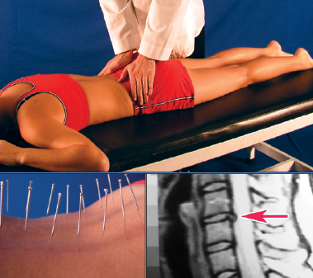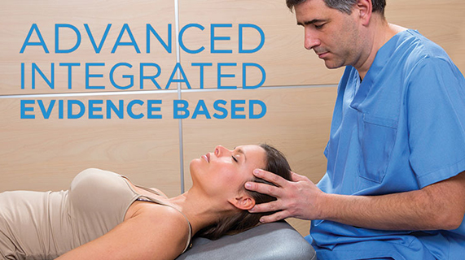

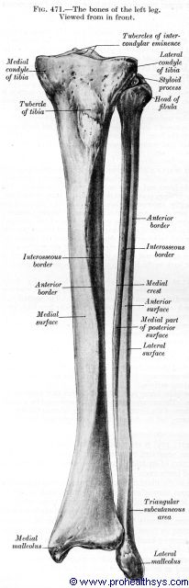

**We Can Help**

1234 Any Street North

Townsville, State 54321

604.521.5520 ph

604.521.5526 fax

www.prohealthsys.com

**ProHealth Clinics**

Your Clinic Logo or Staff Picture

consultation

diagnosis

support

**Prognosis & Prevention**

* **Good, most heal in 8-10 weeks**
* **Future prevention is a fundamental part of our management plan & includes:**
  + Appropriate treatment of the injury to prevent reoccurance
  + Physical therapy exercises to increase range of motion
  + Muscles strengthening and stretching exercises

Professional Health

Your Clinic Name

**History, signs & symptoms**

* Insidious onset of pain with activity or pain with weight bearing
* Pain better at rest, returns with activity
* Usually no history of trauma
* May be associated with an increase and/ or change in activity or training
* Chronic **shin splints (ddx)**

**Condition – What is it?**

* **Partial to complete hairline break in the tibia due to repetitive stress**
* Risk factors:
* Chronic shin splints
* Running
* Dancing
* Female athletes

**How can we help?**

* **Physical therapy:** to improve range of motion, decrease pain, and prevent further injury
* **Hydrotherapy:** contrast hydrotherapy to promote circulation and healing
* **Nutrition:** many vitamins, minerals & botanicals contain pain-relieving, anti-inflammatory & bone healing properties
* **Acupuncture:** may provide pain relief and improve bone repair
* **Diet:** diet modification to improve healing and support bone repair

Ref erences:

1)Martinez, John M, MD.; Calhoun, Jason H, MD, FACS.  *Stress fractures.* Medscape [Internet]. Cited 2014 Jan 11. Available from: <http://emedicine.medscape.com/article/1270244-overview#aw2aab6b3>

2)Vizniak, N. *Orthopedic Conditions Manual.* Professional Health Systems Inc. 2015.

We have the training and experience to work with you as part of your healthcare team.

Acute flare-up to regular maintenance, we can support your return to optimal health.

**Treat the underlying cause.**

**Effective, Comprehensive, holistic & safe.**