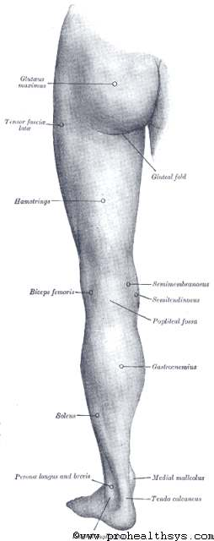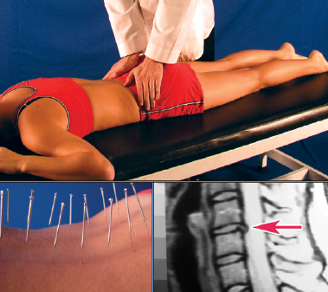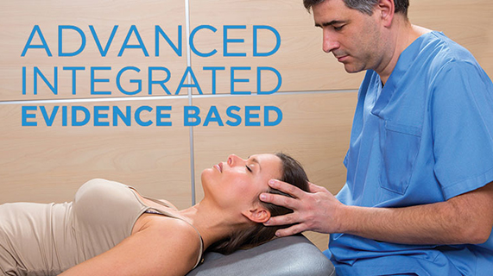

**Varicose Veins**

**We Can Help**

1234 Any Street North

Townsville, State 54321

604.521.5520 ph

604.521.5526 fax

www.prohealthsys.com

**ProHealth Clinics**

Your Clinic Logo or Staff Picture

consultation

diagnosis

support

**Prognosis & Prevention**

* **Most patients experience benefits through conservative care**
* **Future prevention is a fundamental part of our management plan & includes…**
  + **Regular movement or exercise**
  + **Avoid sitting or standing for long periods of time**
  + **Nutritional therapy**

Professional Health

Your Clinic Name

**History, signs & symptoms**

* Dull, aching heaviness, tension, or fatigue in the legs
* Swelling in the lower legs
* Elevation brings relief
* Cosmetic condition
  + Wearing shorts, skirts
* Difficulty in jobs involving standing or sitting for long periods of time
  + Cashiers
  + Desk jobs

**How can we help?**

* **Physical therapy:** to promote circulation and reduce swelling
* **Hydrotherapy:** contrast hydrotherapy to promote circulation and healing
* **Nutrition:** many vitamins, minerals & botanicals contain pain-relieving & vein strengthening properties
* **Acupuncture:** may provide pain relief and improve tissue function

References:

Kumar, Vinay et al. *Robbins & Cotran pathologic basis of disease.* 8th ed. Philadelphia, PA: Saunders Elsevier; 2010.

Cabrera, Chanchal, FNIMH. *Varicose ulcers*. Retrieved March 16, 2014 from file:///C:/Documents%20and%20Settings/Anspan/My%20Documents/Downloads/case%20history%20varicose%20ulcers%20(1).pdf

Kuoch, David, J. *Acupuncture desk reference*. 2nd ed. San Francisco, CA: Acumedwest Inc.

We have the training and experience to work with you as part of your healthcare team.

Acute flare-up to regular maintenance, we can support your return to optimal health.

**Varicose Veins – What are they?**

* Enlarged, twisted veins near the surface of the skin
* Risk factors include:
  + Sitting or standing for long periods of time
  + Heavy lifting
  + Overweight
  + Pregnancy

**Treatment the underlying cause.**

**Effective, Comprehensive, holistic & safe.**